**Project on Bank Loan analysis**

**Aim –** To get accurate information about loan application, total distribute amount by the bank, total amount received by the bank, average interest, average DTI, purpose of the loan and good loan vs bad loan to find out the current situation of loan.

**Problem Statement-** Examine the correlation between various factors such as total loan applications, average Debt-to-Income ratio, average interest rate, loan purpose, and repayment behavior (good loan vs. bad loan) within the banking portfolio. Utilize this analysis to identify significant trends, potential risk factors, and areas for improvement in loan origination, underwriting processes, and customer segmentation strategies to enhance loan portfolio performance and mitigate credit risk effectively.

**Approach in solving the problem-** Analyze loan application data to compare factors like Debt-to-Income ratio, interest rates, and loan purpose between good and bad loans, aiming to identify trends and inform strategies for risk mitigation and loan portfolio optimization. Utilize statistical analysis and predictive modeling to discern significant variables and develop actionable insights for improving loan approval processes and minimizing credit losses within the banking sector.

Top of Form

Bottom of Form

Top of Form

Bottom of Form

**Data-**

Data Rows- 38,576

Data Columns-24

The project is sub divided following sections. These are

* loading Dataset from a CSV file or from a Table.
* Summarization of Data to understand Dataset
* Visualization of data to understand Dataset (chart, Graphs, Gauge etc.)
* Data pre-processing and Data transformation (Not Required in this case as no categorical data is present in the Dataset)
* Finally, we can see the accurate information about the loan

**Data** **Visualization –**

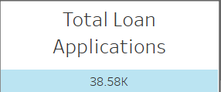

**Fig1. Number of Total loan Applications.**

**Inference:** The card shows the count of total loan application**.**

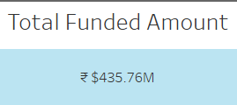

**Fig2. Number of Total funded amount**

**Inference:** The card shows the Total amount disbursed in 2021.

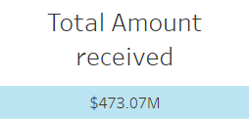

**Fig3. Number of Total Amount Received**

**Inference:** The card shows the Total Amount Received by the bank in 2021.

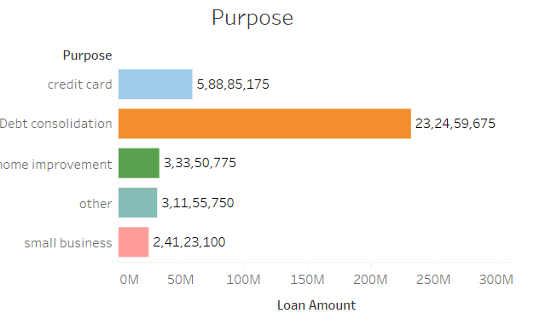

**Fig4. Purpose of Loan   
Inference:** Here we are finding out the top 5 purposes for which people are taking more loans from banks.

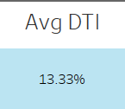

**Fig5. Average percentage of DTI (CIBIL SCORE)  
Inference:**  Here we can see the average percentage of DTI (CIBIL SCORE) in the year 2021.

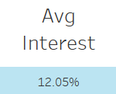

**Fig6. Average Percentage of Interest**

**Inference:**  Here we can see the average percentage of interest in the year 2021.

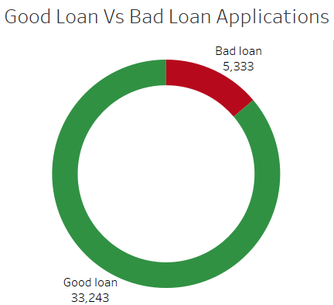

**Fig7. Good loan vs Bad loan Applications.**

**Inference:**  Here we can distinguish between the total count of Good Loan Vs Bad loan applications we had received in the year 2021.

**Conclusions**

In conclusion, our analysis reveals significant differences in key factors such as Debt-to-Income ratio, interest rates, and loan purpose between good and bad loans. These insights underscore the importance of refining loan approval criteria, enhancing risk assessment methodologies, and tailoring customer segmentation strategies to optimize portfolio performance and minimize credit risk within the banking sector.